**PHP Control Structures: If else, Switch Case**

**What is a control structure?**

Code execution can be grouped into categories as shown below

* **Sequential**– this one involves executing all the codes in the order in which they have been written.
* **Decision** – this one involves making a choice given a number of options. The code executed depends on the value of the condition.

A control structure is a block of code that decides the execution path of a program depending on the value of the set condition.

Let’s now look at some of the control structures that PHP supports.

**PHP IF Else**

If… then... else is the **simplest** **control** **structure**. It evaluates the conditions using Boolean logic   
**When to use if… then… else**

* You have a block of code that should be executed only if a certain condition is true
* You have two options, and you have to select one.
* If… then… else if… is used when you have to select more than two options and you have to select one or more

**Syntax** The syntax for if… then… else is;

<?php

if (condition is true) {

block one

else

block two

}

?>

**HERE,**

* “**if (condition is true)”** is the control structure
* “**block one**” is the code to be executed if the condition is true
* **{…else…}**is the fallback if the condition is false
* “**block two**” is the block of code executed if the condition is false

**How it works** The flow chart shown below illustrates how the if then… else control structure works

[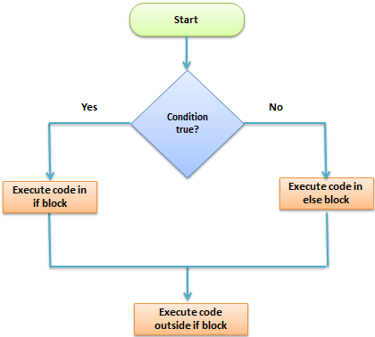](https://www.guru99.com/images/2013/04/if_then_flowchart.png)

**Let’s see this in action** The code below uses “if… then… else” to determine the larger value between two numbers.

<?php

$first_number = 7;

$second_number = 21;

if ($first_number > $second_number){

echo "$first_number is greater than $second_number";

}else{

echo "$second_number is greater than $first_number";

}

?>

**Output:**

21 is greater than 7

**PHP Switch Case**

**Switch… case** is similar to the **if then… else** control structure.

It only **executes** a single block of code depending on the **value** of the condition.

If no condition has been met then the default block of code is executed.

It has the following basic syntax.

<?php

switch(condition){

case value:

//block of code to be executed

break;

case value2:

//block of code to be executed

break;

default:

//default block code

break;

}

?>

**HERE,**

* **“switch(…){…}”** is the control structure block code
* **“case value: case…”** are the blocks of code to be executed depending on the value of the condition
* **“default:”** is the block of code to be executed when no value matches with the condition

**How it works**

The flow chart shown below illustrates how the switch control structure works

[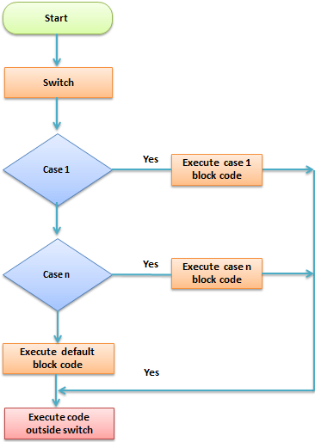](https://www.guru99.com/images/2013/04/switch_flowchart.png)

**Practical example**

The code below uses the switch control structure to display a message depending on the day of the week.

<?php

$today = "wednesday";

switch($today){

case "sunday":

echo "pray for us sinners.";

break;

case "wednesday":

echo "ladies night, take her out for dinner";

break;

case "saturday":

echo "take care as you go out tonight.";

break;

default:

echo "have a nice day at work";

break;

}

?>

**Output:**

ladies night, take her out for dinner

**Summary**

* Control structures are used to control the execution of the program
* The if then... else is when you have more than route block of code to execute depending on the value of the condition
* Switch… case is used to when you have a number of block codes, and you only have to execute one of them depending on the value of the set case.